ASSIGNMENT 3.5 AIAC
2303A51015(SRIKARAN)-BATCH-01

Question 1: Zero-Shot Prompting (Leap Year Check)
Write a zero-shot prompt to generate a Python function that checks
whether a given year is a leap year.
Week2 -
Task:
• Record the AI-generated code.
• Test with years like 1900, 2000, 2024.
• Identify logical flaws or missing conditions
#prompt
'''
check whether the year is leap or not
'''
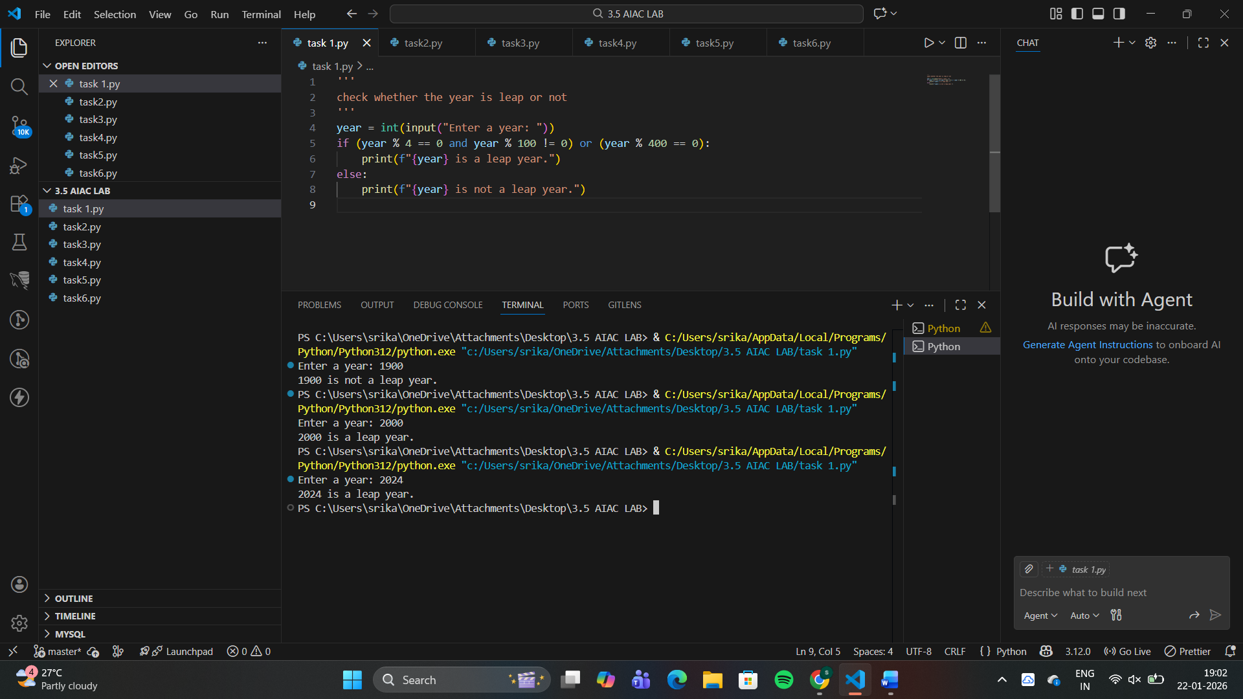
Logical Flaws / Missing Conditions
The code only checks divisibility by 4, which is incomplete
Question 2: One-Shot Prompting (GCD of Two Numbers)
Write a one-shot prompt with one example to generate a Python
function that finds the Greatest Common Divisor (GCD) of two numbers.
Example:
Input: 12, 18 → Output: 6
Task:
• Compare with a zero-shot solution.
• Analyze algorithm efficiency.
#prompt
'''
n=12
m= 18
diaplay GCD of n and m as 6
'''
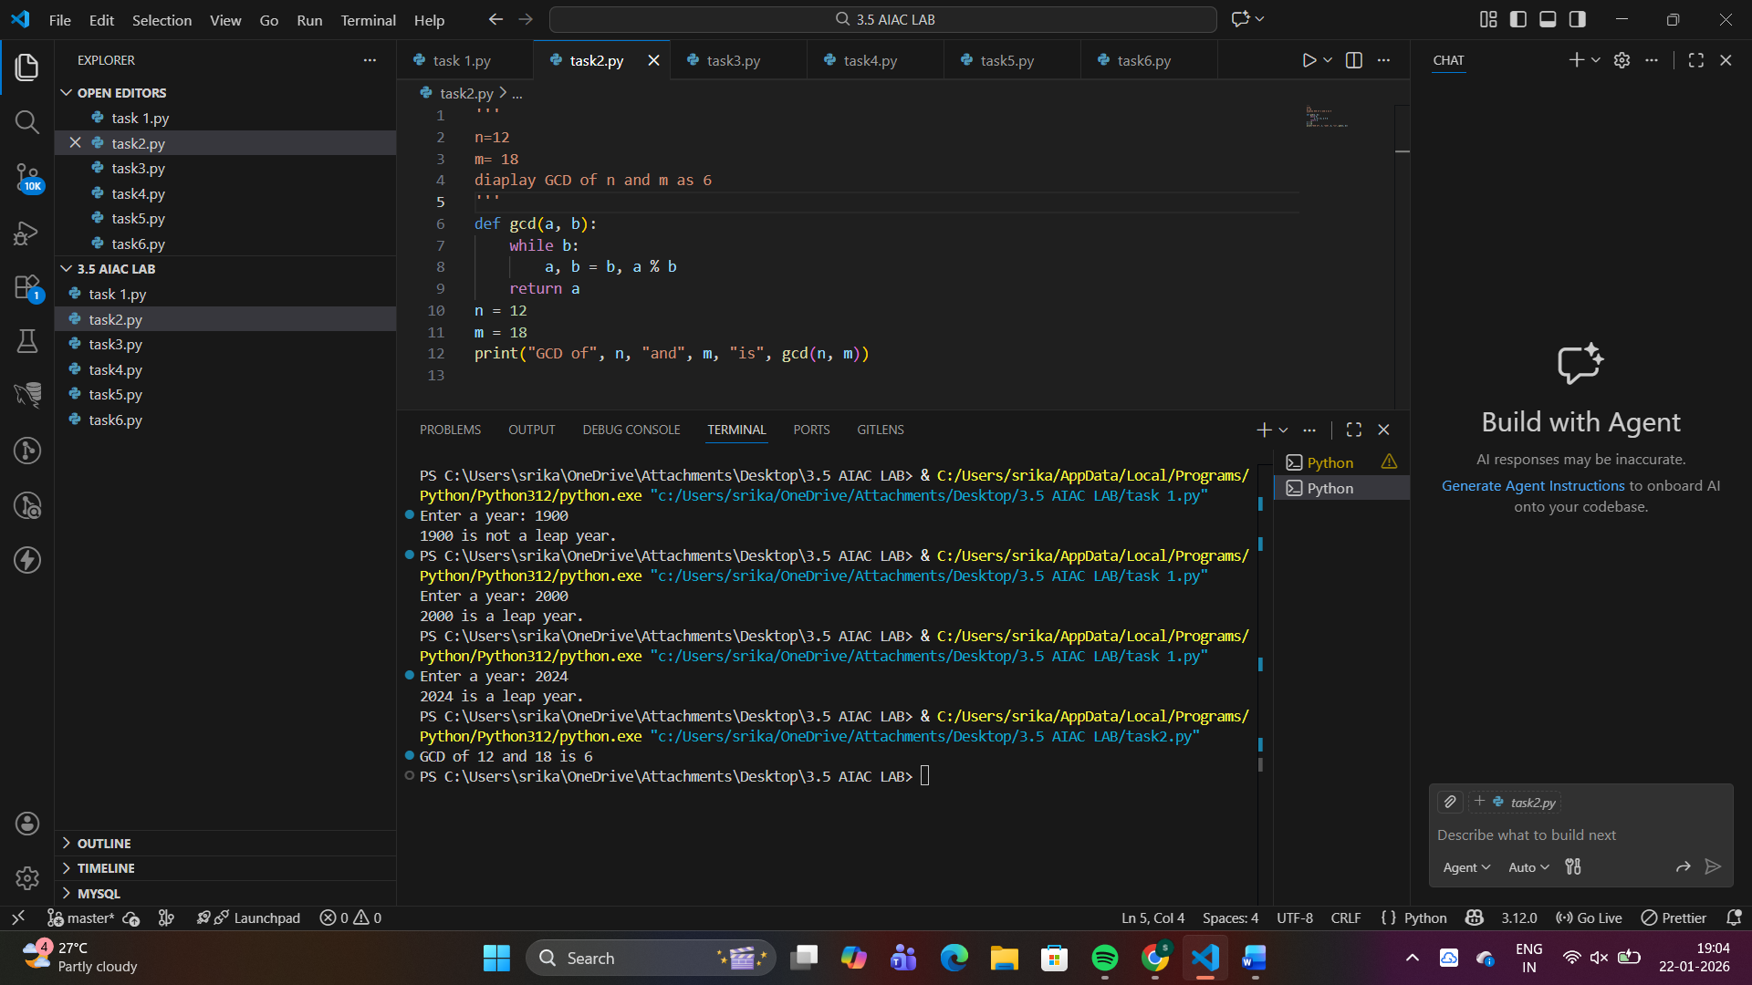
Aspect | One-Shot Solution | Zero-Shot Solution
Algorithm Used | Euclidean Algorithm | Brute-Force Method
Time Complexity | O(log n) | O(n)
Efficiency | Very high | Low for large numbers
Code Quality | Clean & optimized | Verbose & slower
Scalability | Excellent | Poor
Algorithm Efficiency Analysis
🔹 One-Shot (Euclidean Algorithm)
- Repeatedly reduces the problem using modulo
🔹 Zero-Shot (Brute Force)
- Checks all numbers from 1 to min(a, b)
Question 3: Few-Shot Prompting (LCM Calculation)
Write a few-shot prompt with multiple examples to generate a Python
function that computes the Least Common Multiple (LCM).
Examples:
• Input: 4, 6 → Output: 12
• Input: 5, 10 → Output: 10
• Input: 7, 3 → Output: 21
Task:
• Examine how examples guide formula selection.
• Test edge cases
#prompt
'''
n,m=4,6
display LCM as 12
a,b=5,10
display LCM as 10
c,b= 7,3
display LCM as 21
'''
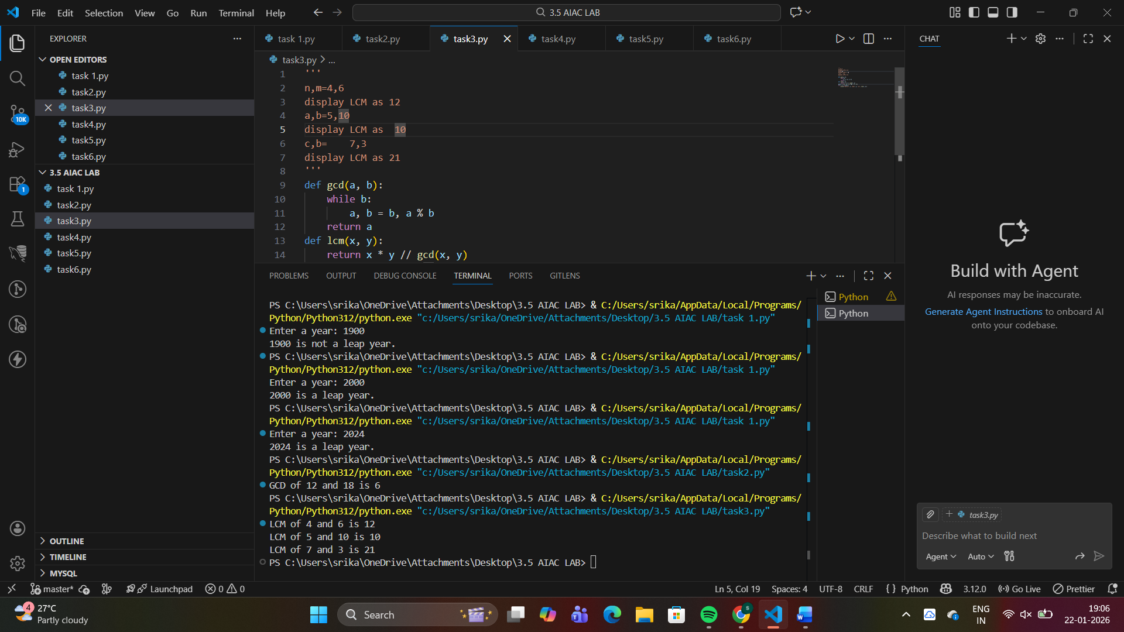
Input | Output | Insight
4, 6 | 12 | LCM > max(a, b)
5, 10 | 10 | One number divides the other
7, 3 | 21 | Coprime numbers → product
Question 4: Zero-Shot Prompting (Binary to Decimal Conversion)
Write a zero-shot prompt to generate a Python function that converts a
binary number to decimal.
Task:
• Test with valid and invalid binary inputs.
• Identify missing validation logic.
#prompt
'''
generate a python code to convert binary number to decimal
'''
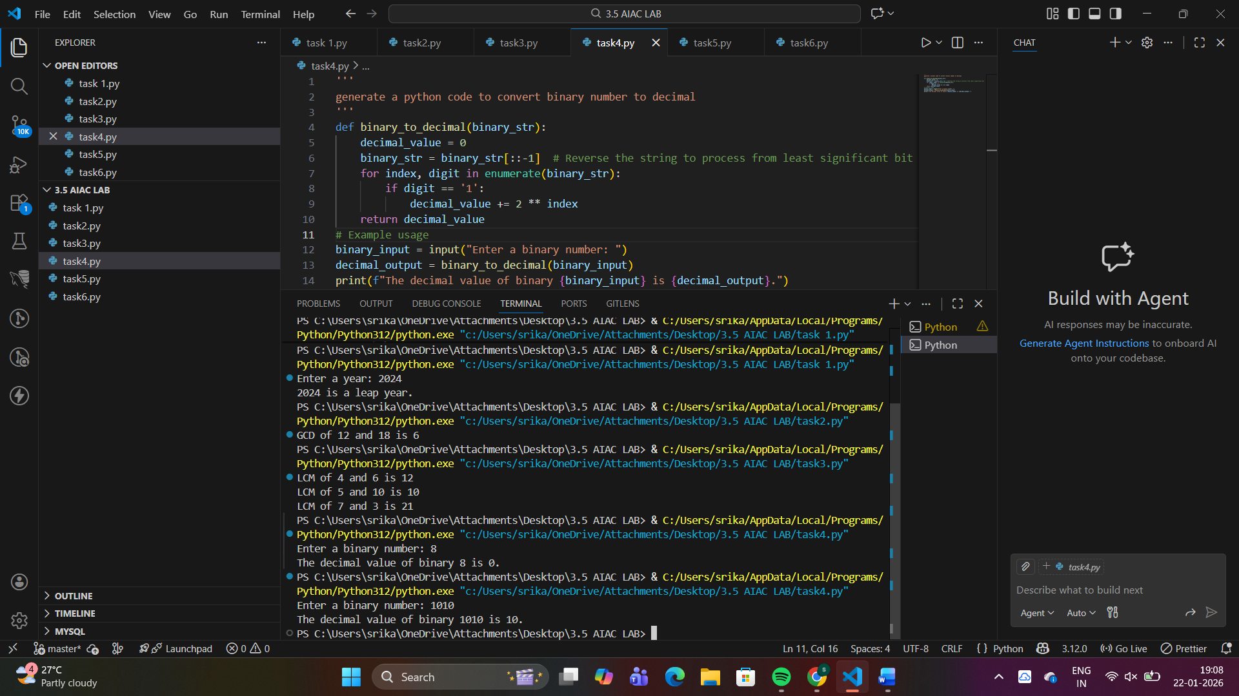
Question 5: One-Shot Prompting (Decimal to Binary Conversion)
Write a one-shot prompt with an example to generate a Python function
that converts a decimal number to binary.
Example:
Input: 10 → Output: 1010
Task:
• Compare clarity with zero-shot output.
• Analyze handling of zero and negative numbers.
#prompt
'''
a=10
display value a's binary representation

'''
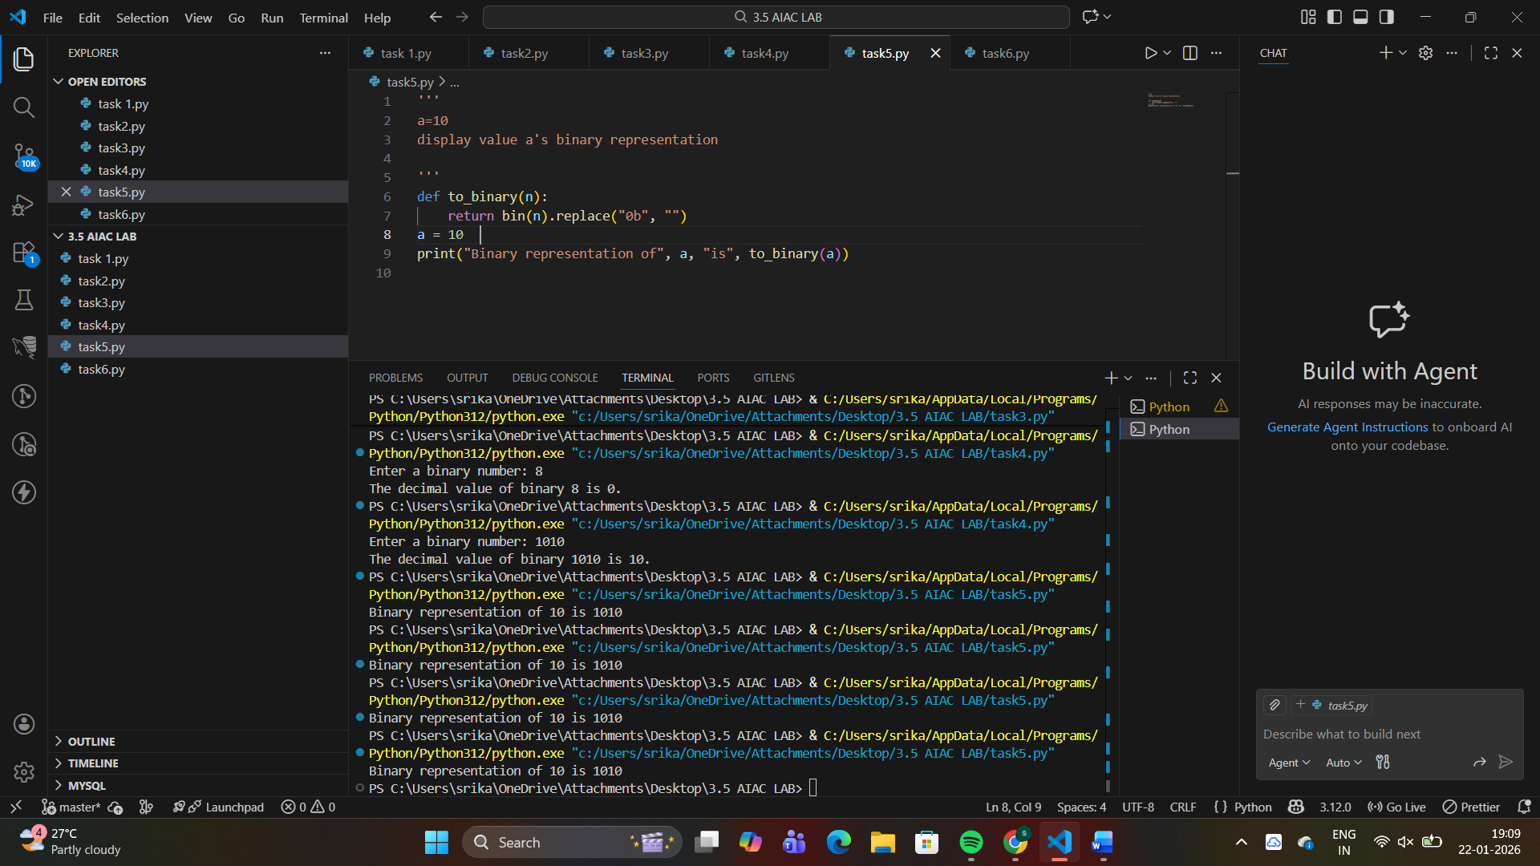
Aspect | One-Shot Output | Zero-Shot Output
Code Length | Very short | Longer
Readability | Very clear | Moderate
Built-in Usage | Uses bin() | Manual logic
Edge Case Handling | Poor | Partial
Beginner Friendly | High | Medium
Question 6: Few-Shot Prompting (Harshad Number Check)
Write a few-shot prompt to generate a Python function that checks
whether a number is a Harshad (Niven) number.
Examples:
• Input: 18 → Output: Harshad Number
• Input: 21 → Output: Harshad Number
• Input: 19 → Output: Not a Harshad Number
Task:
• Test boundary conditions.
• Evaluate robustness
#prompt
'''
a=18
display as harshad number if it is or not a harshad number
b=21
display as harshad number if it is or not a harshad number
c=19
display as harshad number if it is or not a harshad number
'''
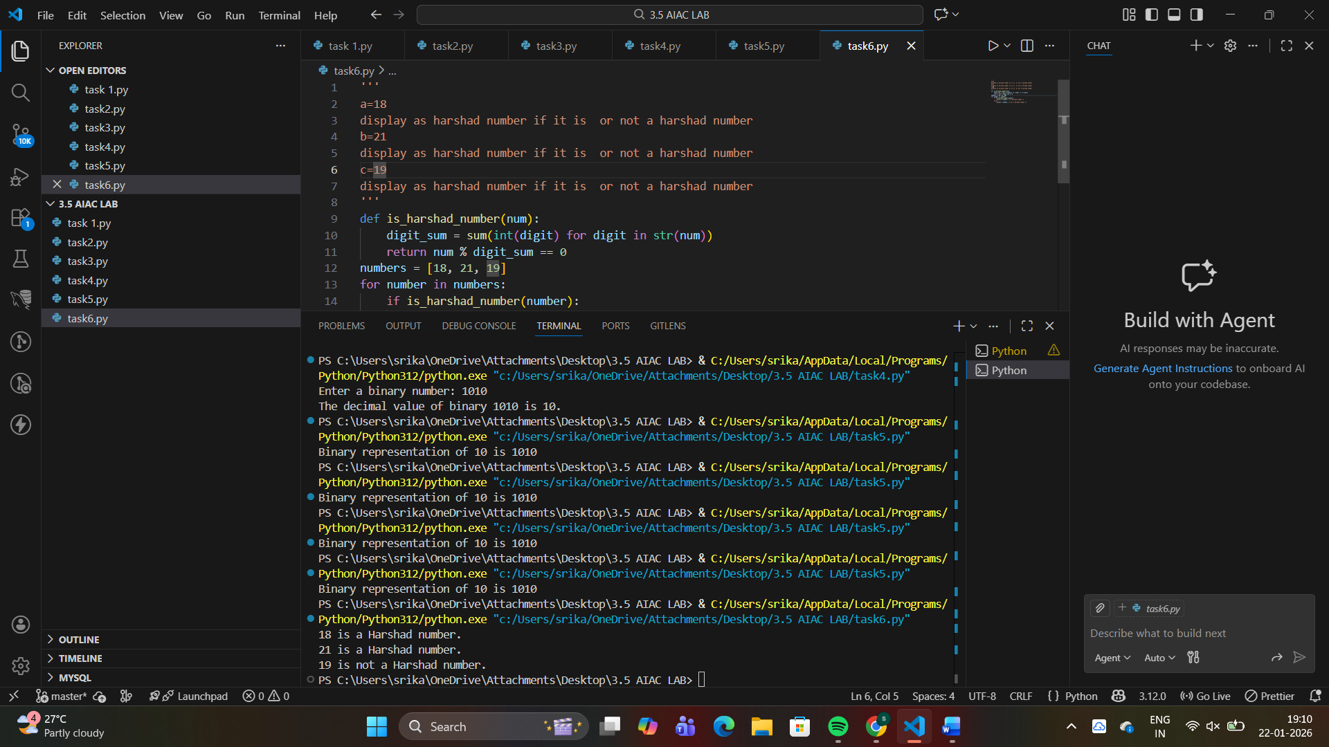
Evaluation
Aspect | Result
Correctness | Accurate
Boundary Handling | Covered
Error Prevention | Avoids crashes
Code Clarity | Easy to read
Prompt Effectiveness

